NARSEE MONJEE INSTITUTE OF MANAGEMENT STUDIES
NMIMS University, Mumbai

Micro Economics for Managers
MBA Capital Market
(2007-08)

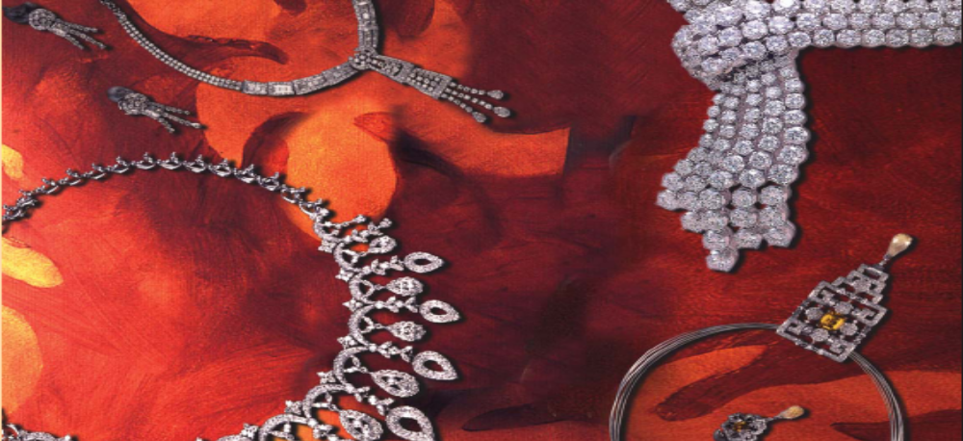
Gems & Jewellery Industry

Su-Raj Diamonds & Jewellery Ltd.
(Final Project Report)

Prepared by:
Ashish Kumar Jain (11)
Mehul Jain (12)
Anthony Abhishek Joseph (14)
Satish Kachhawa (15)

Guidance:
Mr. Deepankar De
Submitted on: 30-Sep-2007

Gems & Jewellery Industry
INTRODUCTION

Gems and Jewellery have been a part of most of the cultures of the world at some point of time or other. From its basic use as currency, it is now used as an instrument to store and display wealth. In the recent past (last 3-4 decades), this industry has shown an impressive growth world wide. The current global market for the sector is estimated at around $85bn USD and has shown a CAGR of 5-10% in the last decade.

On the exports front, Indian gems and jewellery industry has come a far way. In 1966-67, the export turnover of the Gems & Jewellery industry was just Rs. 220mn representing a 3 per cent of total merchandise exports. However, it has now grown to become one of the leading export oriented industries in India recording an export turnover of around Rs. 770bn during 2006-07 and contributing 13.7 per cent of total exports,

The industry is highly export-import oriented, labour intensive and employment oriented. Realising enormous potential of the sector, the Ministry of Commerce, Government of India declared gem and jewellery as a thrust sector for export promotion and formed Gem and Jewellery Export Promotion Council (GJEPC) in 1966. The GJEPC is an all India apex body representing more than 6,500 gem and jewellery traders from India. India's 300,000 traditional jewelers – commonly referred to as the unorganized sector – dominate the country's jewellery retail landscape with a 96 per cent market-share. Keeping in mind that only 4% of the sector is in organized hands, we have selected Su-Raj Diamonds as our company of analysis for its growth potential in the industry and opportunities in the organized sectors.

CLASSIFICATION
Gems & Jewellery Industry

Polished Diamonds

Gem Stones

Gold & Jewellery

Synthetic Stones

The gems and jewellery industry can broadly be categorised in four segments namely polished diamonds, Gem Stones (such as topaz, ruby, emerald etc.), Gold and other precious metal jewellery and Synthetic stones (made of plastic, glass or other materials).

COMPANY ANALYSIS


Su-Raj Diamond and Jewellery Ltd.
- INTRODUCTION

'Su-Raj' is derived from contraction of two names viz. Suresh and Rajnikant, the founders of Su-Raj Group in the early Sixties. Su-Raj Diamonds is a leading diamond manufacturer and exporter, and also a leading player in the international fine gold jewellery market. The company offered its shares to the public in the year 1986 and became the first company in the Industry to opt for public issue in India. The company has two core business, Manufacturing and export of gold, silver & platinum jewellery studded with diamonds, color stones and semi precious stones as well as plain jewellery and manufacture and export of polished diamonds.

- CORE BUSINESS

Manufacture and export of gold, silver & platinum jewellery studded with diamonds, color stones and semi precious stones as well as plain jewellery. Manufacture and export of polished diamonds.

- INFRASTRUCTURE

The Company is equipped with machinery, facilities and processors that ensure quality merchandise and timely delivery. The Jewellery manufactured by the Company is at par with the most advanced manufacturing centers in the world. The Company has expanded its integrated facility for the manufacture of Diamonds and Jewellery. Company has strategically located five jewellery divisions in India at Bangalore, Kolkata, Cochin, Goa and Chennai and two diamond divisions at Surat and Jodhpur.

- MARKETING

The Company has extensive marketing network throughout the length and breadth of the Globe. The Company is focusing more on markets like oil rich east middle east since it is a strategically located market of huge potential.

The Company has world wide marketing network with associate offices at major international location viz., New York, Antwerp, Bangkok, Hong Kong and Tokyo. Promotional activities on a world wide scale also include advertising in the leading trade journals and participation in the major international jewellery exhibitions. The Company is one of the leading players in the bullion business with a wide distribution network. At present, the company sells its products to Jewellery Wholesalers in New York, Antwerp, Tokyo, Hong Kong and UAE.
- MARKET STRUCTURE
  - DIAMONDS
Su-Raj Diamonds and Jewellery Limited is having four state of the art factories equipped with machineries of best international standards to ensure its dominant infrastructure capability in diamond manufacturing. Each factory is a centre of excellence in diamond manufacturing, combining traditional skills with the latest international standards in manufacturing. Today, the strong infrastructure capabilities of Su-Raj enables it to manufacture diamonds of any configuration ranging from 0.005pts to 3cts, and calibrated Princess diamonds from 0.03pts to 1cts, in colors from D to M and qualities ranging from IF to I3. Diamond business constitutes around 46% of Su-Raj’s Business.

5.2 GOLD/SILVER/PLATINUM
At company designs are created by a team of nearly 100 professionals and churn out more than 700 new designs every month. Company’s artists use innovative techniques and designs to keep them updated in the ever-changing world of jewellery design. Su-Raj employs the latest technology available in the world to manufacture Gold Jewellery and uses advanced infrastructure for manufacturing process. The entire company products are hallmarked. The revenue generated from the jewellery part of the company is around 56% of the total revenue of the company.

- FINANCIAL PERFORMANCE

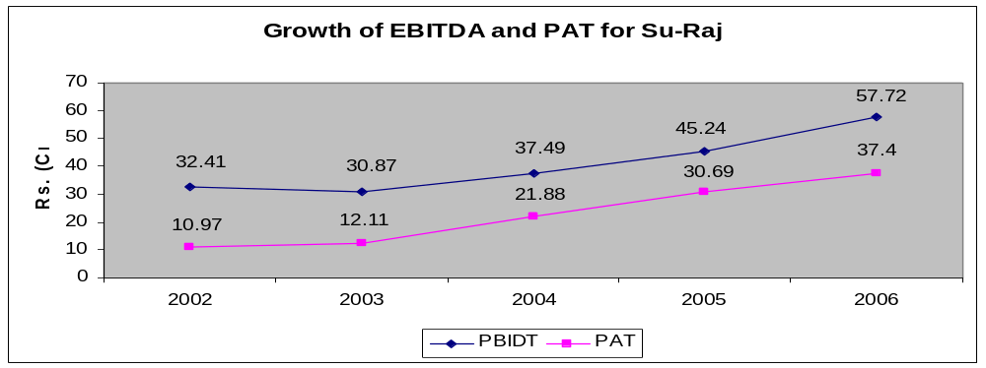

In the last financial year net profit for the company has increased by ~22% (from Rs. 30.69 cr. in 2005-06 to Rs. 37.4 cr. in 2006-07). Company has also observed a 19% growth in the operating margins and the EPS has increased from Rs. 7.67 to Rs. 9.33. In the last financial year, the company has declared dividend of 15% and has managed to put Rs. 30 cr. from the earnings to the general reserves. The company share is traded at bourses at Rs. 60.60 with PE around 5.0.

SWOT ANALYSIS

STRENGTHS

- Strong Reserves and Surplus backed by an additional Rs. 10 cr. to Foreign Exchange and metal price fluctuation reserve.
- 19% growth rate in operating income and 22% growth in Net Profit.
- Strong risk management focus as part of strategy.
- Investments in upgrading the technology and setting up new units in Kolkotta and Bangalore.
- Manufacture handicraft jewellery along with branded jewellery to cater to diverse markets.
- Long standing relationship with dealers in US, Antwerp, Dubai etc.

WEAKNESS

- A smaller player in size compared to the rest of the competitors such as Rajesh Exports and Gitanjali Gems and Jewellery, and therefore would not be able to enjoy the same benefits of returns to scale as the others.
- No well established brand like other firms (e.g. Gili from Gitanjali Gems and Jewellery or Tanishq from Tata).
- At present, no tie up with the retail sector firms which could have increased the reach of the Su-Raj to the non-accessible market.
- Lacked infrastructure to cater to the retail customers abroad. Company sells most of its product to the wholesalers in which case they have much of the bargaining power. Such power with the consumer puts pressure on the margins of a firm and Su-Raj diamond does not have bargaining power here.

OPPORTUNITIES

- Gems and Jewellery to grow by 12% (as calculated by the demand forecasting).India’s share is projected to be around 1.5 to 2 percent of the global industry.
- Tax regime to be structured to develop India as a global hub for gems and jewellery.
- Increase in wealth leading to increase consumption is expected to boost demand for this sector.
- Global Silver to Gold ratio is improved to 15:3 from 7:3 in 2000 in the world market; this is mainly because of a younger generation’s preference for a white metal than gold.
- Increase demand in Middle East and North American countries, forming the largest segment and offering the highest growth in the previous financial year.
  - North America Increase of 23.25 %
  - Europe Increase of 6.02%
  - Middle East Increase of 51.67%
  - Asia Increase of 19.02%
- Availability of high skilled labor in production of gold jewellery.
THREATS

- Emergence of China as a competitor.
- Unusual increase in the price of gold and rough diamonds.
- Fluctuation in currency, especially appreciation of rupee against the dollar.
- Change in fashion trends.
- As per the CMIE data, only 4% of the gems and jewellery sector is in the organized hands, Tanisq, Gili (subsidiary of Gitanjali Gems), Oysterbay, being the major players from whom company faces a lot of competition.
- Substitution of gold and other banking products as a better source of investment has lead to the decline in the consumption of silver.
- The reduction of consumption of silver in the Indian market. Witnessed a decrease of 53.1% from 1996 to 2005 in consumption.
- Low availability of skilled labor in processing of diamonds.
- Infrastructure bottlenecks, absence of latest technology.
- China, Sri Lanka and Thailand's entry in small diamond segment.

RECENT STRATEGIES

- To manufacture handicraft jewellery along with branded to cater to diverse market.
- To strengthen in markets like US, Europe and Middle East, as there is spurt in demand for fashion jewellery along with traditional jewellery. Su-Raj now has six wholly owned subsidiaries to cater to domestic and overseas market.
- To expand B2B business by increasing its retail clients like Tanishq, Khazana, Alukkas and Vummidi
- Su-Raj Diamonds & Jewellery has set up an exclusive factory outlet in Bangalore. The company has invested about Rs400m on these initiatives. It also plans to open another factory outlet in Goa in six months at an investment of Rs400m.
- Company has plans of increasing presence by opening retail outlets.

COMPETITIVE ANALYSIS
In the above matrix, the significant firms operating in the industry are shown in decreasing order of revenue.
Company | EPS(TTM)  (rs./Share) | Price  (Rs.) | Market capital (Rs. Cr.) | PE | Net Sales  (Rs. Cr.)
Rajesh Exports | 27.41 | 554.2 | 2047.4 | 20.22 | 5283.09
Getanjali | 13.88 | 255.85 | 1509.52 | 18.43 | 1621.24
Su Raj | 11.9 | 54.5 | 220.62 | 4.58 | 1219.9
Asian Star | 25.82 | 1329.4 | 1418.47 | 51.49 | 1206.67
Suashish Diamonds | 16.81 | 177.95 | 371.2 | 10.59 | 933.47
Vaibhav Gems | 8.8 | 188.85 | 521.04 | 21.46 | 219.46

The nearest competitors of the Su-Raj Diamonds are Getanjali Gems and Jewellery and Asian star. By the comparative analysis, following points turn up:
- The market capital of the firm is around Rs. 220 cr. only and the revenue is in excess of Rs. 1200 cr., which is around 5.5 times. But for the most of the competitors, this ratio is less then 1, showing that Su-Raj is able to use its capital more efficiently.
- Like Getanjali’s Gili, Su-Raj does not have a well established brand in the market place. A brand increases the recognition of the firm in terms of the quality of the product and services and a consumer’s reliability on the firm increases and in such a case the firm becomes able to charge more then the traditional price. Su-Raj diamonds does not have such an advantage.
- Like Tanishq, Su-Raj diamonds does not have a well retail chain of its products which could be made available to the consumer directly.
- Like Rajesh Exports, Su-Raj does not process high quality diamonds and gold constitute a considerable part of the exports. Consumer’s demand are not much price sensitive for the high quality diamonds and a firm can ask for more price for a high quality product.

DEMAND FORECASTING

Objective of this report is to estimate and forecast the future demand for diamond export industry and for Su-Raj Diamonds and analyze the growth trend. The method which has been used to estimate the demand for diamond exports is Regression Model. For this, we have selected variables out of the factors which influence the demand.
Various factors affecting the diamond exports are listed as below:
  - Total import of rough diamonds in India
  - Currency rate fluctuations (Rs/USD)
  - Import price of rough diamond
  - Export price of finished diamond
  - World demand
  - Availability of cheap labor
Factors chosen for the final regression analysis for demand forecast of polished diamonds are
X1 → Import of rough diamonds
X2 → Export price
X3 → Currency rate
Y → Diamond Export Estimate

Year | Exports  (Rs. mn) | Imports  (Rs. mn ) | International Prices (USD/Carat) | Exchange Rate  (Rs/USD) | Estimated Export  (Rs. Mn) | Difference from the Actual
2002 | 28,346.5 | 20,098.8 | 182 | 48.39 | 27690.707 | -655.8
2003 | 34,297.9 | 30,504.2 | 191 | 46.59 | 33920.513 | -377.4
2004 | 39,550.6 | 33,064.0 | 229 | 45.27 | 44875.120 | 5,324.5
2005 | 50,073.4 | 34,242.0 | 233 | 43.84 | 47064.074 | -3,009.3
2006 | 53,096.9 | 38,619.3 | 247 | 45.21 | 50932.175 | -2,164.7
2007 | 48,858.8 | 39,977.0 | 236 | 43.13 | 49741.508 | 882.7

Using the above available data, with the help of Microsoft excel, Regression analysis has been done and following linear relationship has been established:

Y = 4396 + 0.27415 * X1 + 249.98796 * X2 - 570.66153 * X3

Based upon the above derived result, estimation for diamond exports for next three years has been done. Apart from the simple regression model, sensitivity analysis has also been done to check the effect of various variables individually. Below graph represents the estimated growth in the diamond exports for next three years:
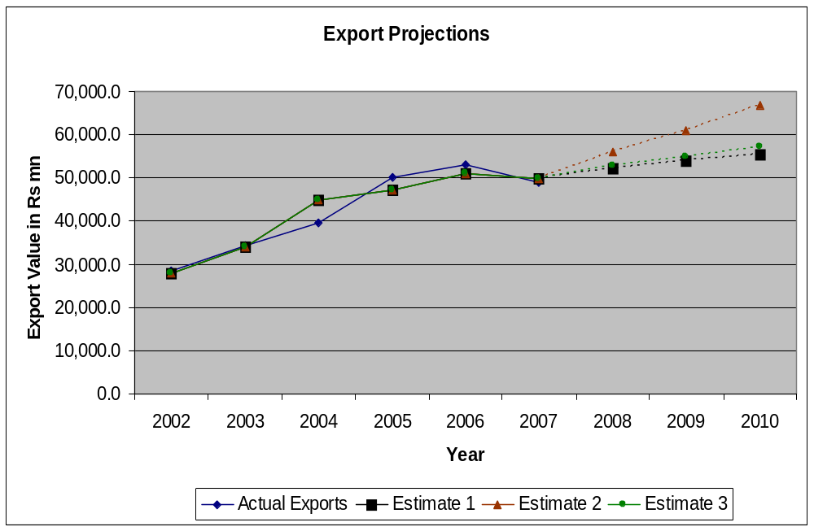

ESTIMATION FOR DIAMOND EXPORTS FOR INDIAN INDUSTRY

The three estimates, used for the estimation of Indian diamond exports gives us the following figure:
Estimation 1 → ~3% CAGR
Estimation 2 → ~12% CAGR
Estimation 3 → ~6% CAGR

Hence, based upon the above data, we can conclude that the future outlook of the Indian diamond exports looks bright even if we take the balanced approach which gives a modest growth rate of 6% as compared to 12% growth rate with the aggressive approach.

ESTIMATION FOR THE DIAMOND EXPORTS OF SU-RAJ DIAMONDS

For the estimation of the firm’s revenue, we have used extrapolation method. In the last four years, the CAGR of revenue is around 28% for the firm while the industry is growing at a pace of 16% since last 4 years. Growth rate of the firm has outpaced the industry rate by 1.75 times. If Su-Raj diamonds is able to continue so, its growth rate for the next three years should be around 20% (taking 12% growth for the industry).

RECOMMENDATIONS

Following are the recommendations for Su-Raj diamonds to increase its market share in the country and increase its exports demand:
- Introduce a jewellery or diamond brand
- Increase presence in the retail segment
- Built strategic tie-up with the established firms to supply its products
- explore new markets in Middle East
- Invest in technology, specially for the processing of high quality and high carat diamonds
- Apart from the old tradition Indian jewellery designs, concentrate on the modern designs as sought in international markets
- As there is a scarcity of the skilled labor in diamond processing industry, Su-Raj diamonds should invest in developing skilled labor.

APPENDIX

REGRESSION DATA
Year | Exports  (Rs. mn) | Imports  (Rs. mn ) | International Prices (USD/Carat) | Exchange Rate  (Rs/USD) | Estimated Export  (Rs. Mn) | Difference from the Actual
2002 | 28,346.5 | 20,098.8 | 182 | 48.39 | 27690.70766 | -655.8
2003 | 34,297.9 | 30,504.2 | 191 | 46.59 | 33920.51346 | -377.4
2004 | 39,550.6 | 33,064.0 | 229 | 45.27 | 44875.12017 | 5,324.5
2005 | 50,073.4 | 34,242.0 | 233 | 43.84 | 47064.07425 | -3,009.3
2006 | 53,096.9 | 38,619.3 | 247 | 45.21 | 50932.1756 | -2,164.7
2007 | 48,858.8 | 39,977.0 | 236 | 43.13 | 49741.50886 | 882.7
2008 | Estimate 1 | 44,774.2 | 236 | 41 | 52272.22172 | 3% growth
2009 | Estimate 1 | 50,147.1 | 236 | 41 | 53745.24997 | 3% growth
2010 | Estimate 1 | 56,164.8 | 236 | 41 | 55395.04161 | 3% growth
2008 | Estimate 2 | 44,774.2 | 250 | 41 | 55812.05133 | 12% growth
2009 | Estimate 2 | 50,147.1 | 265 | 41 | 61037.29896 | 12% growth
2010 | Estimate 2 | 56,164.8 | 281 | 41 | 66664.44315 | 12% growth
2008 | Estimate 3 | 44,774.2 | 236 | 40 | 52842.88325 | 6% growth
2009 | Estimate 3 | 50,147.1 | 236 | 39 | 54886.57304 | 6% growth
2010 | Estimate 3 | 56,164.8 | 236 | 38 | 57107.02621 | 6% growth

REGRESSION STATISTICS

Regression Statistics
Multiple R | 0.954285047
R Square | 0.910659951
Adjusted R Square | 0.776649877
Standard Error | 4660.699911
Observations | 6

ANOVA
 | df | SS | MS | F | Significance F
Regression | 3 | 442835397.5 | 147611799.2 | 6.795458927 | 0.130970826
Residual | 2 | 43444247.33 | 21722123.66
Total | 5 | 486279644.8

 | Coefficients | Standard Error | t Stat | P-value
Intercept | 4396.94903 | 138859.933 | 0.031664635 | 0.977615332
X Variable 1 | 0.274158432 | 0.79727172 | 0.343870759 | 0.763730894
X Variable 2 | 249.9879667 | 176.9031714 | 1.413134455 | 0.29316315
X Variable 3 | -570.661533 | 2500.333158 | -0.228234198 | 0.84067555

